Assignment 4
Name:-Yadnesh Patil
PRN:-123B1D034
Assignment 4: SQL Computations in an E-Commerce Application
1. Customers : Stores customer details.
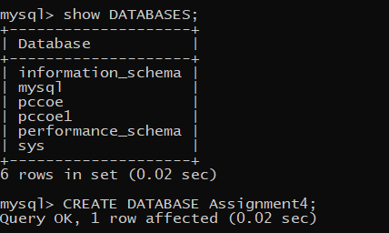
CREATE TABLE Customers (customer_id INT PRIMARY KEY,name VARCHAR(50),email VARCHAR(100), city VARCHAR(50), age INT);
mysql> INSERT INTO Customers (Customer_id, Name, Email, City, Age) VALUES
-> (67, 'Atharva', 'atharva.zope23@pccoepune.org', 'New York', 32),
-> (18, 'Virendra', 'virendra.rajput@pccoepune.org', 'Los Angeles', 28),
-> (10, 'Prateek', 'prateek.mishra@pccoepune.org', 'Chicago', 45),
-> (11, 'Vishwajeet', 'vishwajeet.patil@pccoepune.org', 'New York', 33),
-> (58, 'Onkar', 'onkar.kulkarni@pccoepune.org', 'Los Angeles', 24),
-> (78, 'Aryan', 'aryan.kumar@pccoepune.org', 'Chicago', 27),
-> (44, 'Shruti', 'shruti.sharma@pccoepune.org', 'Los Angeles', 31),
-> (52, 'Shashwati', 'shashwati.das@pccoepune.org', 'New York', 35),
-> (23, 'Tanaya', 'tanaya.joshi@pccoepune.org', 'Pune', 23),
-> (2, 'Adwait', 'adwait.kamble@pccoepune.org', 'New York', 2);
mysql> SELECT * FROM Customers;
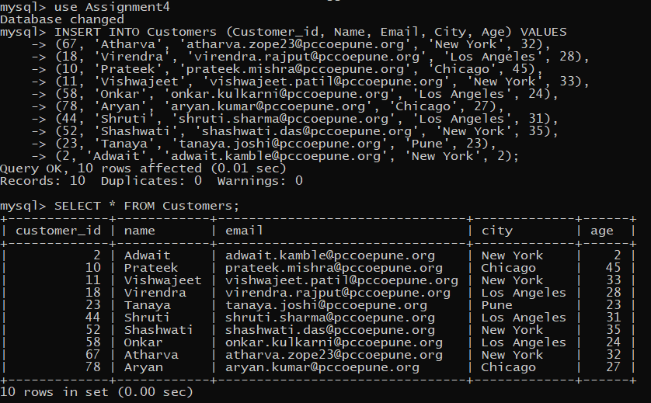

2. Orders :Stores order details placed by customers.
CREATE TABLE Orders (order_id INT PRIMARY KEY, customer_id INT, order_date DATE, total_amount DECIMAL(10,2), status VARCHAR(20), FOREIGN KEY (customer_id) REFERENCES Customers(customer_id) );
mysql> INSERT INTO Orders (order_id, customer_id, order_date, total_amount, status) VALUES
-> (101, 67, '2025-01-01', 300.00, 'Completed'),
-> (102, 2, '2025-01-05', 550.00, 'Completed'),
-> (103, 10, '2024-12-15', 400.00, 'Processing'),
-> (104, 18, '2025-01-10', 100.00, 'Completed'),
-> (105, 23, '2024-12-30', 600.00, 'Completed'),
-> (106, 44, '2025-01-25', 150.00, 'Pending'),
-> (107, 52, '2025-01-28', 700.00, 'Processing'),
-> (108, 58, '2025-01-27', 200.00, 'Completed'),
-> (109, 11, '2025-01-26', 450.00, 'Completed'),
-> (110, 78, '2025-01-31', 650.00, 'Completed');
Query OK, 10 rows affected (0.01 sec)
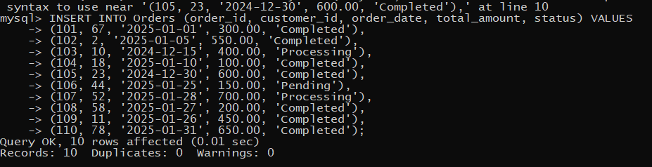
mysql> SELECT * FROM Orders;
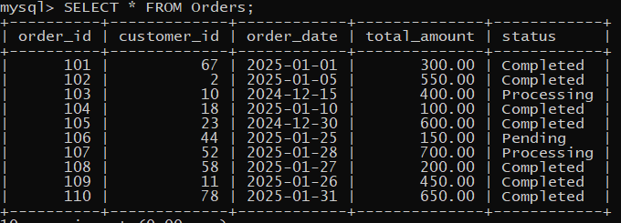
3. Products : Stores product details.
CREATE TABLE Products (product_id INT PRIMARY KEY, name VARCHAR(50), category VARCHAR(50),price DECIMAL(10,2),stock INT);
INSERT INTO Products (product_id, name, category, price, stock) VALUES
-> (1, 'Smartphone', 'Electronics', 700.00, 10),
-> (2, 'Basic Phone', 'Electronics', 30.00, 3),
-> (3, 'Tablet', 'Electronics', 400.00, 15),
-> (4, 'Gaming Laptop', 'Electronics', 1500.00, 8),
-> (5, 'T-shirt', 'Clothing', 20.00, 50),
-> (6, 'Headphones', 'Electronics', 200.00, 0),
-> (7, 'Shoes', 'Footwear', 80.00, 12),
-> (8, 'Backpack', 'Accessories', 40.00, 6),
-> (9, 'Socks', 'Footwear', 20.00, 12),
-> (10, 'Play Station', 'Electronics', 200.00, 20);
mysql> SELECT * FROM Products;
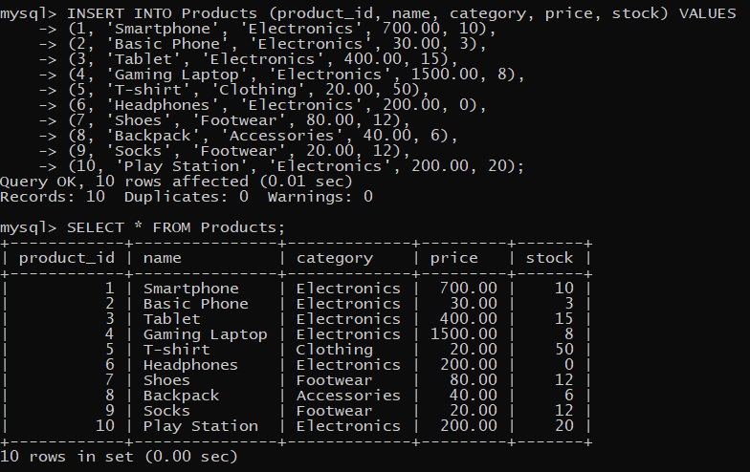

4. Order_Items : Stores products included in an order.
CREATE TABLE Order_Items ( order_item_id INT PRIMARY KEY, order_id INT, product_id INT, quantity INT, subtotal DECIMAL(10,2), FOREIGN KEY (order_id) REFERENCES Orders(order_id), FOREIGN KEY (product_id) REFERENCES Products(product_id));
mysql> INSERT INTO Order_Items (order_item_id, order_id, product_id, quantity, subtotal) VALUES
-> (1, 101, 1, 1, 700.00),
-> (2, 102, 3, 2, 800.00),
-> (3, 103, 2, 10, 300.00),
-> (4, 104, 4, 1, 1500.00),
-> (5, 105, 6, 1, 200.00),
-> (6, 106, 7, 1, 80.00),
-> (7, 107, 8, 2, 80.00),
-> (8, 108, 5, 5, 100.00),
-> (9, 109, 7, 1, 80.00),
-> (10,110, 10, 1, 200.00);
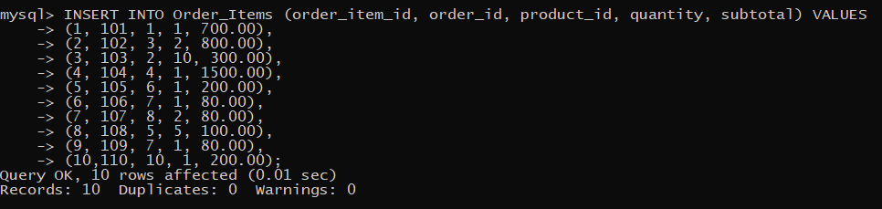
mysql> SELECT * FROM Order_Items;
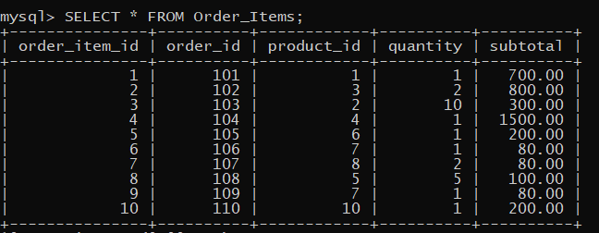

Solve following queries :
1. Find the total amount spent by customer ID 67 (sum of all their orders).
mysql> SELECT SUM(total_amount) AS total_spent FROM Orders WHERE customer_id = 67;
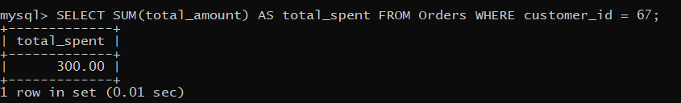
2. Find the total revenue generated from all orders.
mysql> SELECT SUM(total_amount) AS Total_Revenue FROM Orders;
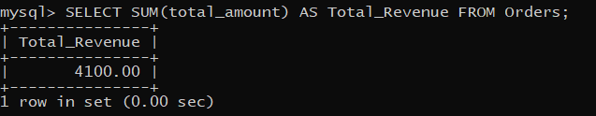
3. Calculate the stock value (price × stock) for each product.
mysql> SELECT name AS product_name, (price * stock) AS stock_value FROM Products;
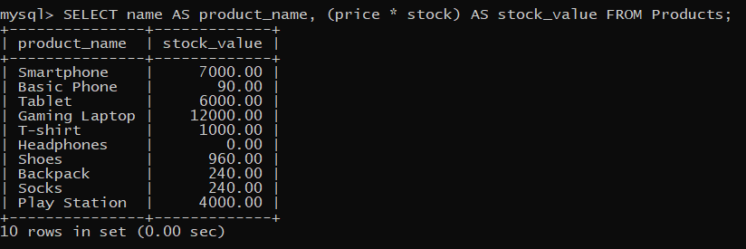4. Retrieve customers who are above 30 years old and live in "New York".
mysql> SELECT * FROM Customers WHERE age>30 AND city='New York';
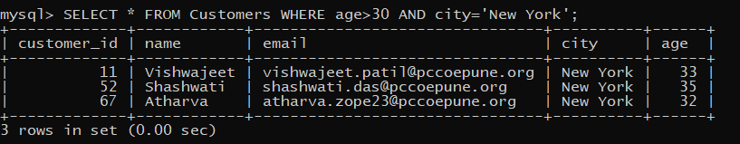

5. Find customers who either live in "Los Angeles" or have placed an order worth more
than $500.
mysql> SELECT DISTINCT c.name
-> FROM Customers c
-> LEFT JOIN Orders o ON c.customer_id = o.customer_id
-> WHERE c.city = 'Los Angeles' OR o.total_amount > 500;
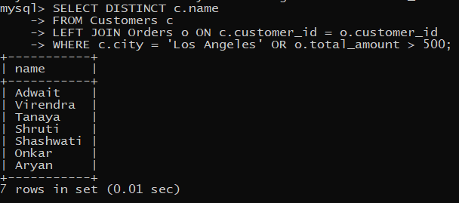

6. List products that are in stock but cost less than $50.
mysql> SELECT name FROM Products WHERE stock > 0 AND price < 50;
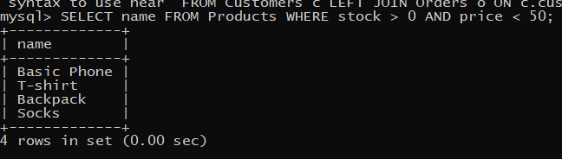

7. Find Products That Have Less Than 5 Items in Stock
mysql> SELECT name FROM Products WHERE stock < 5;
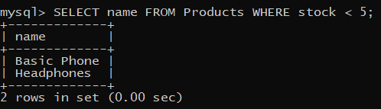

8. Find orders that are not completed (status is not 'Completed').
mysql> SELECT * FROM Orders WHERE status != 'Completed';
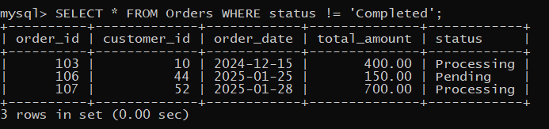

9. Find products that are out of stock or belong to the "Electronics" category.
mysql> SELECT * FROM Products WHERE stock = 0 OR category = 'Electronics';
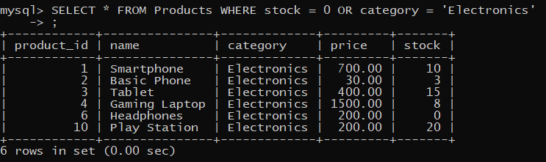

10. List all email addresses that belong to PCCOE.
mysql> SELECT * FROM Customers WHERE email LIKE '%@pccoepune.org';
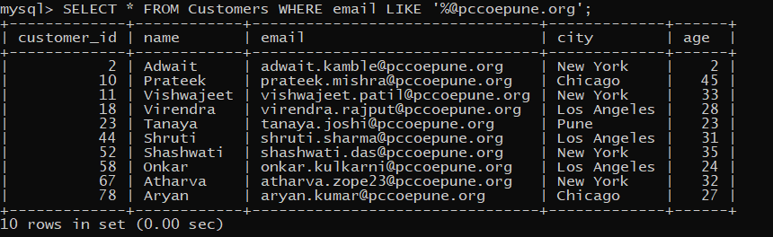

11. Find product names containing the word "Phone".
mysql> SELECT name FROM Products WHERE name LIKE '%Phone%';
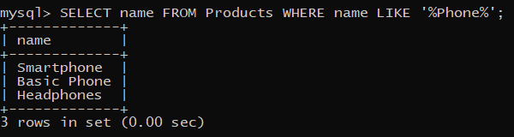

12. Find customers whose names have exactly 5 characters.
mysql> SELECT * FROM Customers WHERE CHAR_LENGTH(name) = 5;
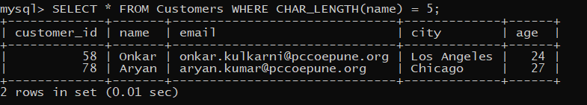
13. Find Products That Have "Laptop" or "Tablet" in Their Name
mysql> SELECT name FROM Products WHERE name LIKE '%Laptop%' OR name LIKE '%Tablet%';
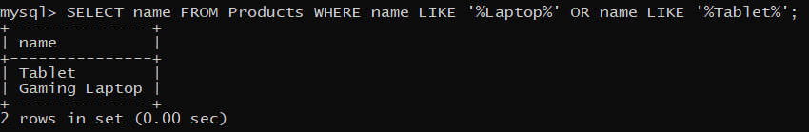

14. Retrieve orders placed in the year 2024.
mysql> SELECT order_id FROM Orders WHERE YEAR(order_date) = 2024;
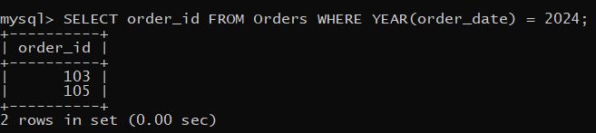

15. Find customers who live in "New York", "Los Angeles", or "Chicago".
mysql> SELECT name FROM Customers WHERE city IN ('New York', 'Los Angeles', 'Chicago');
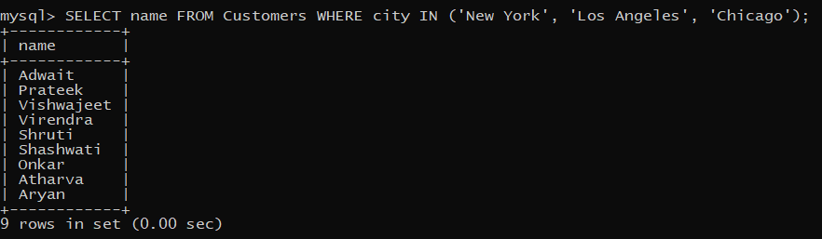

16. List products that do not belong to the 'Electronics' or 'Clothing' categories.
mysql> SELECT * FROM Products WHERE category NOT IN ('Electronics', 'Clothing');
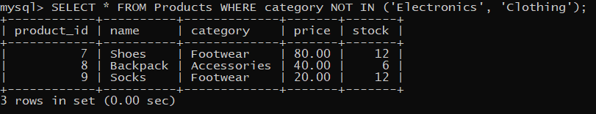

17. Find orders placed by customers with IDs 67,2 or 78.
mysql> SELECT * FROM Orders WHERE customer_id IN (67, 2, 78);
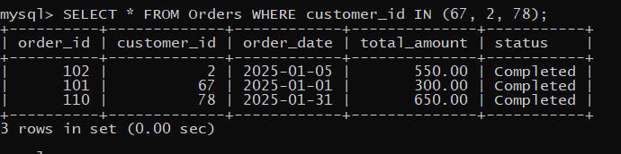

18. Find customers who have not placed any orders.

19. Show All Orders Placed in the Last 30 Days
mysql> SELECT * FROM Orders WHERE order_date >= CURDATE() - INTERVAL 30 DAY;
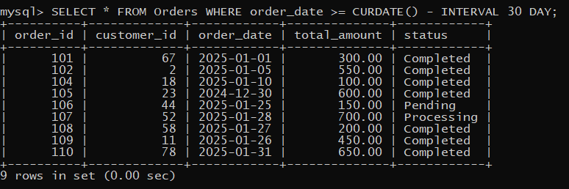

20. Find Orders Where the Total Amount is an Exact Multiple of 100
mysql> SELECT * FROM Orders WHERE MOD(total_amount, 100) = 0;
